1. 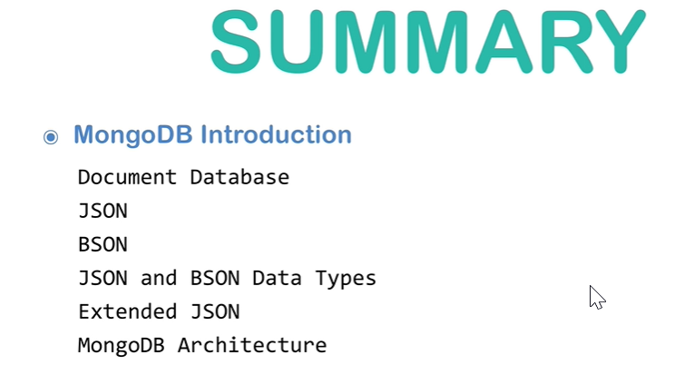
2. Let’s summarize what we discussed in this module.
   1. We have talked about document db and its difference from a relational db.
   2. JSON and BSON formats.
   3. JSON and BSON data types.
   4. Purpose of “Extended JSON Format”.
      1. Its two modes of operations.
         1. Shell Mode
         2. Strict Mode.
   5. MongoDB Structure and Architecture.
   6. Remote MongoDB Management.